

See discussions, stats, and author profiles for this publication at: [https://www.researchgate.net/publication/371240977](https://www.researchgate.net/publication/371240977_Solid-oxide_fuel_cells_A_critical_review_of_materials_for_cell_components?enrichId=rgreq-35971e8e6d16b8e006dd8c749a2f2a8f-XXX&enrichSource=Y292ZXJQYWdlOzM3MTI0MDk3NztBUzoxMTQzMTI4MTE2NDUwMjA4OUAxNjg1NzQxNTcwMjE0&el=1_x_2&_esc=publicationCoverPdf)

[Solid-oxide fuel cells: A critical review of materials for cell components](https://www.researchgate.net/publication/371240977_Solid-oxide_fuel_cells_A_critical_review_of_materials_for_cell_components?enrichId=rgreq-35971e8e6d16b8e006dd8c749a2f2a8f-XXX&enrichSource=Y292ZXJQYWdlOzM3MTI0MDk3NztBUzoxMTQzMTI4MTE2NDUwMjA4OUAxNjg1NzQxNTcwMjE0&el=1_x_3&_esc=publicationCoverPdf) **Article***in*MRS Communications · June 2023

DOI: 10.1557/s43579-023-00371-0

|  |  |
| --- | --- |
| CITATIONS  0 | READS  5 |

**Some of the authors of this publication are also working on these related projects:**

Li-ion batteries.[View project](https://www.researchgate.net/project/Li-ion-batteries-14?enrichId=rgreq-35971e8e6d16b8e006dd8c749a2f2a8f-XXX&enrichSource=Y292ZXJQYWdlOzM3MTI0MDk3NztBUzoxMTQzMTI4MTE2NDUwMjA4OUAxNjg1NzQxNTcwMjE0&el=1_x_9&_esc=publicationCoverPdf)

Surface exchange and diffusion of protonic species.[View project](https://www.researchgate.net/project/Surface-exchange-and-diffusion-of-protonic-species?enrichId=rgreq-35971e8e6d16b8e006dd8c749a2f2a8f-XXX&enrichSource=Y292ZXJQYWdlOzM3MTI0MDk3NztBUzoxMTQzMTI4MTE2NDUwMjA4OUAxNjg1NzQxNTcwMjE0&el=1_x_9&_esc=publicationCoverPdf)

All content following this page was uploaded by [Mudasir A Yatoo](https://www.researchgate.net/profile/Mudasir-Yatoo?enrichId=rgreq-35971e8e6d16b8e006dd8c749a2f2a8f-XXX&enrichSource=Y292ZXJQYWdlOzM3MTI0MDk3NztBUzoxMTQzMTI4MTE2NDUwMjA4OUAxNjg1NzQxNTcwMjE0&el=1_x_10&_esc=publicationCoverPdf) on 02 June 2023.

The user has requested enhancement of the downloaded file.



*MRS Communications*   
© The Author(s) 2023   
https://doi.org/10.1557/s43579-023-00371-0

Prospective

**Solid‑oxide fuel cells: A critical review of materials for cell componen[ts](http://crossmark.crossref.org/dialog/?doi=10.1557/s43579-023-00371-0&domain=pdf)**

**Mudasir A. Yatoo [,](http://orcid.org/0000-0003-0970-5683)** Department of Materials, Imperial College London, Exhibition Road, London SW7 2AZ, UK

**Faiza Habib,** Department of Chemistry, University College London, Gordon St, London WC1H 0AJ, UK   
**Akhtar Hussain Malik,** Department of Chemistry, Government Degree College Sopore, Sopore, J & K 193201, India **Mohsin Jahan Qazi,** Meinig School of Biomedical Engineering, Cornell University, Ithaca, NY 14853, USA **Sharique Ahmad,** Aligarh Muslim University, University Polytechnic, Aligarh 202002, India   
**Mohd Azhardin Ganayee,** Department of Chemistry, Indian Institute of Technology Madras, Chennai 600036, India **Zubair Ahmad,** School of Chemical Engineering, Yeungnam University, Gyeongbuk 38541, Republic of Korea

Address all correspondence to Mudasir A. Yatoo at **m.yatoo15@imperial.ac.uk** and Zubair Ahmad at **Zubair7157@yu.ac.kr**

(Received 30 January 2023; accepted 17 May 2023)



**Abstract**   
Solid-oxide fuel cells are efficient devices for the conversion of chemical to electrical energy and a typical solid-oxide fuel cell consists of a solid electrolyte, cathode, and anode. In the last few decades, researchers have been working extensively on materials development for different compo-nents of these devices. In this review article, we briefly discuss the requirements for different components and review prominent materials families explored by the scientific community. As the search for greener energy alternatives such as solid-oxide fuel cells has intensified manifold due to the climate change emergency, a substantial literature was produced on the materials development of these devices and, therefore, we believe a brief review article dedicated to the same will be valuable for the scientific community, particularly new young entrant researchers in the field.

**Introduction**   
Many electrochemical conversion and storage technologies such as Li-ion and solid-state batteries, fuel cells and capaci-tors are being heavily investigated to decarbonise our environ-ment.[1–8] . Fuel cells are one of the promising technologies and depending on the nature of the electrolyte used in the fuel cell that there are various types of fuel cells: Solid-oxide fuel cell (SOFC), Molten carbonate fuel cell (MCFC), Polymer electrolyte (Proton Exchange) Membrane fuel cell (PEMFC), Phosphoric acid fuel cell (PAFC), Direct methanol fuel cell (DMFC) and Alkaline fuel cells (AFC). Broadly these fuel cell types can also be classified as high-temperature devices, such as SOFC and MCFC, and low-temperature devices such as PEMFC, PAFC, DMFC and AFC. The operating temperature of different fuel cell types tends to depend on the nature of the electrolyte being used and is also reflected in the applications of various fuel cell types.

SOFCs, in particular, have attracted much attention in recent times. This increased interest in SOFCs stems from the fact that SOFCs have many advantages over other types of fuel cells. The flexibility of fuel, which allows the use of hydrogen, carbon dioxide, methane, and other hydrocarbons to power the cells is certainly a primary one. Further benefits include higher efficiency, a step towards a hydrogen-based economy, low emissions, relatively low cost and scalability, which allows the stacking of a required number of individual cells in series depending on the amounts of power needed in a particular device. It is in this context that SOFCs have assumed prime importance among the different types of fuel cells, and we, therefore, believe that a concise review article briefly

discussing promising materials families in the field would be relevant for researchers in the field. For comprehensive long reviews, we invite the reader to cited review articles here.[9–12] A typical SOFC consists of a solid electrolyte, which sepa-rates the anode and cathode from each other. The cathode acts as a reduction site and reduces the oxygen being inserted into the system at the cathode site itself. The oxide ions migrate via the electrolyte to the anode where they oxidise the fuel, pro-ducing water, heat and more importantly electrons, to perform useful work (Fig. 1).[13]   
The oxygen reduction reaction (ORR) occurs at the cathode and the oxide ions produced are transported via an electrolyte to the anode (Eq. 1). It is here at the anode site that the oxide ions react with fuel (hydrogen gas) to produce electrons (Eq. 2). The electrons generated at the interface of the anode and elec-trolyte are transported to an external circuit for useful work through the anode. The electrons finally arrive at the cathode and continue the process.[14]

Cathode Reaction : O2(g) + 4e−→2O2−, (1)

Anode Reaction : 2H2(g) + 2O2−→2H2O(g) + 4e, (2)

Overall Reaction : 2H2(g) + O2(g) →2H2O(g). (3)

Apart from the anode, cathode and electrolyte, an intercon-nect is used to connect the individual cells in series to gener-ate useful amounts of power. In simple terms, the intercon-nect material is required to combine the current generated by individual cells, and thus, should ideally possess good elec-tronic conductivity. In addition, it should be chemically stable

Vol.:(0123456789)

MRS COMMUNICATIONS·VOLUME XX · ISSUE xx ·www.mrs.org/mrc1

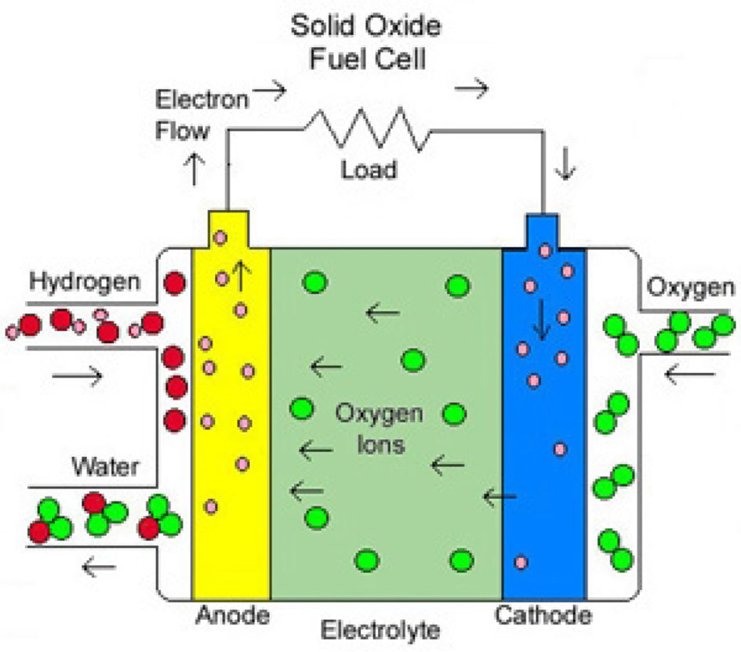



**Figure 1.** Schematic diagram highlighting the key features of the operation of a solid-oxide fuel cell. Reproduced with permission

from Ref. 13.

concerning both anode and cathode materials, and stable in both oxidising and reducing atmospheres. In the following sec-tions of the paper, requirements for different components and prominent materials families fulfilling the said requirements will be reviewed in detail.

**Materials for cathodes**   
The cathode, being the site for the oxygen reduction reaction (ORR), is highly instrumental in determining the performance of a cell. As electrons are necessary for the reduction of oxy-gen molecules, superior electronic conductivity of the cathode material is the primary requirement. Low or no chemical reac-tion with other cell components, compatible thermal expansion coefficient (TEC), and high catalytic activity for the reduction of an oxygen molecule are other requirements for the cathode material. The porous microstructure of the cathode material further enhances the ORR as it ensures the access of oxygen molecules to the cathode surface, and thus, extends the active region beyond the restricted triple phase boundary (TPB).

In pure electronic conducting cathode materials such as ­La1−*x*Sr*x*MnO3−δ (LSM), ORR is limited to a very narrow TPB region, the air/cathode/electrolyte interface (Fig. 2). The air/ electrolyte interface is immaterial as far as the ORR rate is concerned because the commonly used electrolyte materials are catalytically inactive.

Although there is the technical possibility of ORR occur-ring at the air/cathode interface because of insignificant ionic conduction of pure electronic conductor cathode materials, the oxide ions produced fails to migrate to the anode for use-ful work. Thus, the practical region for the ORR to occur in such materials is a very narrow TPB. It is here that so-called mixed-ionic electronic conducting (MIEC) cathode materials

2MRS COMMUNICATIONS·VOLUME XX · ISSUE xx ·www.mrs.org/mrc

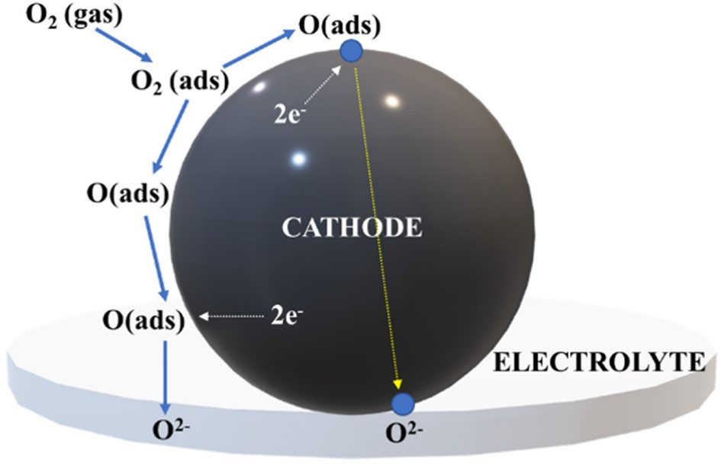

**Figure 2.** Schematic representation of the oxygen reaction at MIEC cathode material. Reproduced with permission from Ref. 15.

assume crucial importance. The mixed conductivity of MIEC cathode materials lets the system to extend the otherwise nar-row ORR region and, thus, increase the efficiency of the cell (Fig. 2).[15–17] In this regard, the last decade has seen signifi-cant research activity in developing MIEC materials for SOFC cathodes based on perovskites, double perovskites, Ruddles-den–Popper phases and other layered oxide materials.

**Substituted lanthanum manganite**   
In high-temperature SOFCs, ­La1−*x*Sr*x*MnO3-δ (LSM), has been the material of choice for cathodes and has, thus, been explored extensively.[18,19] The material adopts the perovskite structure and doping with strontium replaces lanthanum in the structure and enhances the electronic conductivity of the material by increasing the hole carriers.[20] Doping the material with Sr results in the oxidation of ­Mn3+ to ­Mn4+ and leaves the oxygen content of the material intact. Thus, the material achieves a superior electronic conductivity, in the range of 200–300 ­Scm−1 at 900°C.[18] But because of the limits imposed by either reac-tivity with other cell components and/or TEC compatibility, the doping level is usually kept under 30 mol per cent.[10] On increasing Sr levels beyond this limit, TEC ­incompatibility[19] and reactions with other cell components such as the forma-tion of ­SrZrO3 and ­La2Zr2O7 with YSZ electrolyte have been observed (Table I).[21,22]   
The major challenge, however, with LSM as a cathode has been its poor oxide-ion conductivity, of the order of ­10–7—10–8 S ­cm−1 at 800°C.[38] The formation of a composite of LSM with a material of high ionic conductivity has been explored in the hope that this limitation of low ionic conductivity could be resolved.[39] Ostergard et al*.* by using the composites of LSM + YSZ reduced area-specific resistance (ASR) from 2.7 Ω ­cm2 obtained by using pure LSM to 0.5 Ωcm2 for an LSM + YSZ composite operating at 1000°C.[39] However, because of long-term thermal and mechanical degradation problems with LSM cathode materials and their low inher-ent oxide-ion conductivity, a search for better materials for IT-SOFCs continues. The problem arises from the fact that at

**Prospective**



**Table I.** Properties of some relevant SOFC cathode materials.

|  |  |  |  |
| --- | --- | --- | --- |
| Material composition | Total conductivity (S/cm) | Ionic conductivity (S/cm) | TEC (× ­10–6 °C−1) |
| LaMnO3 | 71 (700°C)[23] | – | 9.5–10.75 (25–1000 °C)[24] |
| La0.8Sr0.2MnO3−δ | 150(500°C)[25] | 4.2 × ­10–10 (750°C)[26] | 11.8 (30–1000 °C)[25] |
| La0.6Sr0.4MnO3−δ | 125 (700°C)[27] | – | 11.7–12.2 (25–1000 °C)[25] |
| La0.6Sr0.4CoO3−δ | 1084 (1000°C)[28] | 0.22 (800°C)[29] | 20.5 (30–1000°C)[29] |
| La0.8Sr0.2CoO3−δ | 1291 (1000°C)[28] | 4.9 × ­10–4 (750°C)[30] | 19.7 (100–900°C)[31] |
| La0.6Sr0.4Co0.2Fe0.8O3−δ | 320 (700°C)[31] | 8 × ­10–3 (800°C)[29] | 15.3 (100–600°C)[31] |
| La2NiO4+δ | 85 (700°C)[32] | 4 × ­10–2 (800°C)[33] | 13.8 (75–900°C)[34] |
| La4NiO10±δ | 87 (800°C)[35] | – | 11.5 (250–800°C)[36] |
| Pr4NiO10±δ | 90 (600°C)[37] | – | 12 (25–1000°C)[37] |

high operating temperatures, polarisation losses are negligible but once the temperature is lowered to the intermediate range, polarisation losses become significant and, thus, negatively impact the cell efficiency by decreasing the kinetics associated with ORR and charge transport at the cell cathode. The cathode materials based on LSM further suffer from a severe deleterious problem of strontium segregation, which will be discussed later.

**Substituted lanthanum cobaltite**   
LaCoO3 is again a perovskite like LSM and possesses better electronic conductivity than LSM.[40] The main problem, how-ever, has been the ­stability[19] of this material which has been tackled by doping the system with Sr which replaces Ln in the structure to give the strontium-substituted cobaltite perovskites (LSC: ­La1−*x*Sr*x*CoO3−δ).[30] LSC is a mixed conductor mate-rial and has shown good ionic conductivity and ORR catalytic properties.[41–43] The major issue with LSC, however, is its high TEC, of the order of 20 × ­10–6 ­K−1. When this consider-ably high TEC is compared to the commonly used electrolytes like YSZ and CGO (~12 × ­10–6 ­K−1), compatibility issues with other cell components come to the fore and render the material problematic.[44,45]   
It has been reported that the high TEC of LSC cathodes originates from octahedrally coordinated cobalt ion transitions between low- and high-spin states of the ­Co3+ ­3d6 ion.[45] In light of this knowledge, Co has been substituted with Fe to pro-duce the state-of-the-art cathode material, ­La1−*x*Sr*x*Co1−*y*Fe*y*O3−δ(LSCF). ­La0.6Sr0.4Co0.2Fe0.8O3−δ (LSCF6428) is the most prom-ising and studied composition of these materials. The electronic conductivity of this material is significant, ranging from 350 to 250 S ­cm−1 in 600–800 temperature range °C.[44] This signifi-cant electronic conductivity of the material originates from the mixed valencies ­Fe3+/Fe4+ and ­Co3+/Co4+, which is essentially the result of La substitution by Sr. Equally important benefit of this substitution is the formation of oxygen vacancies in the LSCF system, which ultimately contributes to the ionic conductivity of this MIEC cathode material, with ­10–2 S ­cm−1 ionic conductivity at 800°C being reported by Teraoka et al*.*[46] Further, the material also has TEC in the range of 15 × ­10–6 ­K−1, which is in the compatible range of other cell components.[44]

The primary limitation of LSCF6428 occurs when it is used with the commonly used electrolyte because it reacts with YSZ and negatively impacts cell performance with time. This reduces the flexibility of this promising cathode material, and thus, it has primarily been used with the CGO electrolyte, with which it, fortunately, does not react.[47] However, because of the common use of the YSZ electrolyte, several attempts have been made to make LSCF6428 worka-ble with YSZ. A common approach to tackle deleterious reac-tivity has been to incorporate the ceria barrier layer between the electrolyte and cathode.[48,49] This has also helped in improving the relatively higher ASR that pure LSCF affords, 0.3 Ω ­cm2 at 700°C,[50] which is well above the target value of 0.15 Ω ­cm2.[51] Dusastre et al*.* reduced the ASR of pure LSCF by making composites of LSCF with CGO, reporting an ASR of 0.16 Ω ­cm2 at 700°C, almost halving the polarisa-tion resistance.[52] Wang and Mogensen reduced it further to the remarkable value of 0.026 Ω ­cm2 at 700°C with CGO and 0.12 Ω ­cm2 at 700°C with YSZ electrolyte coated with a thin layer of CGO.[53] But because of the complexity associated with the use of composites as cathodes, there is the possibil-ity of a reaction between CGO and YSZ to form the less ionic conducting phase, (Ce, Zr, Gd, Y)O2−δ and it has been reported that such phases are formed and are responsible for reducing the cell performance.[54]   
Above all, the main problem with the promising LSCF cathode materials is their degradation with time during cell operation. This problem chiefly manifests itself in strontium segregation and chromium poisoning. Both of these problems drastically reduce cell performance. When in operation, Sr selectively segregates towards the cell surface to form a SrO layer at the cathode surface, which effectively stops the ORR from occurring at the air/cathode interface.[55,56] The chromium poisoning problem emanates from the necessity of using inter-connects to connect the individual cells in series to generate the required amounts of power for practical purposes. The com-monly used material for interconnects contains chromium, and it vaporises during cell operation. The harmful impact of chro-mium vapours comes from its deposition on cathode materials, thereby degrading their performance with time.[57]

MRS COMMUNICATIONS·VOLUME XX · ISSUE xx ·www.mrs.org/mrc3



There have been various attempts to resolve this cathode degradation but not with profound success yet. Use of electri-cal polarisation to de-segregate the ­strontium[58,59] and use of acid-etching to reduce the formation of passivating (Ce, Zr, Gd, Y)O2−δ ­layers[56,60] and also an attempt to stop Cr poisoning by ­coating[61] the steel interconnects have been used but with less success.

Another related cathode composition is the doped lanthanum ferrite; ­LaxSr1−*x*Fe*y*Ni1−*y*O3−δ (LSFN), with ­La0.6Sr0.4Fe0.8Ni0.2O3−δ (6428) as the optimum composition. The material shows electronic conductivity of 300 S ­cm−1 at 900°C with a reasonable TEC of 14 × ­10–6 ­K−1,[62] but they also come with their problems of forming insulating phases such as ­La2Zr2O7 and ­SrCoO3 at the interface when used with YSZ as an electrolyte, which further degrades the performance of the cell.

Another class of materials, derived from the perovskite structure are the oxide materials known as double perovskites with the general formula AA’B2O5+δ where A is a rare-earth cation, A’ is an alkaline-earth metal cation, and B is a transition metal cation. In these phases, there is cation ordering of the rare-earth and alkaline-earth metal layers along the (001) axis. This leads to a doubling of the c parameter when compared to the c parameter of the parent perovskite phase.[63] The material further is an oxygen-deficient system with oxygen vacancies mainly located in the rare-earth layer. Two compositions, in particular, ­GdBaCo2O5+δ (GBCO) and ­PrBaCo2O5+δ (PBCO), have been studied extensively.[64–67] The materials have MIEC properties but suffer from relatively lower performance, and thus, composites of GBCO too have been developed for increased electrochemical performance.[68]   
LSCF is the most promising material for IT-SOFC cath-odes but because of the degradation issues and strontium seg-regation discussed earlier, the search for alternative IT-SOFC cathode materials continues. One family suggested as potential IT-SOFC cathodes are the Ruddlesden–Popper phase materi-als. One of the materials of this family, ­La2NiO4+δ adopts the ­K2NiF4-type structure and has been widely studied because of its remarkable oxide-ion conductivity.

**Ruddlesden–Popper phases**   
S. N. Ruddlesden and P. Popper reported a new class of mate-rials with the overall formula of ­An+1BnO3n+1, in 1958.[69] The structure consists of ­nABO3 perovskite layers alternating between two AO rock-salt ­layers[70] and the number of per-ovskite polyhedral units packed between rock-salt units of the structure decides the phase of the material (Fig. 3).[71] Since the perovskite structure allow accommodating oxygen defects and Ruddlesden–Popper (RP) phases contain perovskite layer/s in their structure, it is one of the reasons behind the expec-tation that these materials could work as promising oxygen conductors. It indeed has been found to be true; it is the unique structural features of lower-order phases such as ­La2NiO4+δ(LNO), ­Pr2NiO4+δ (PNO), and ­Nd2NiO4+δ (NNO) which per-mit them to accommodate a substantial amount of interstitial

4MRS COMMUNICATIONS·VOLUME XX · ISSUE xx ·www.mrs.org/mrc

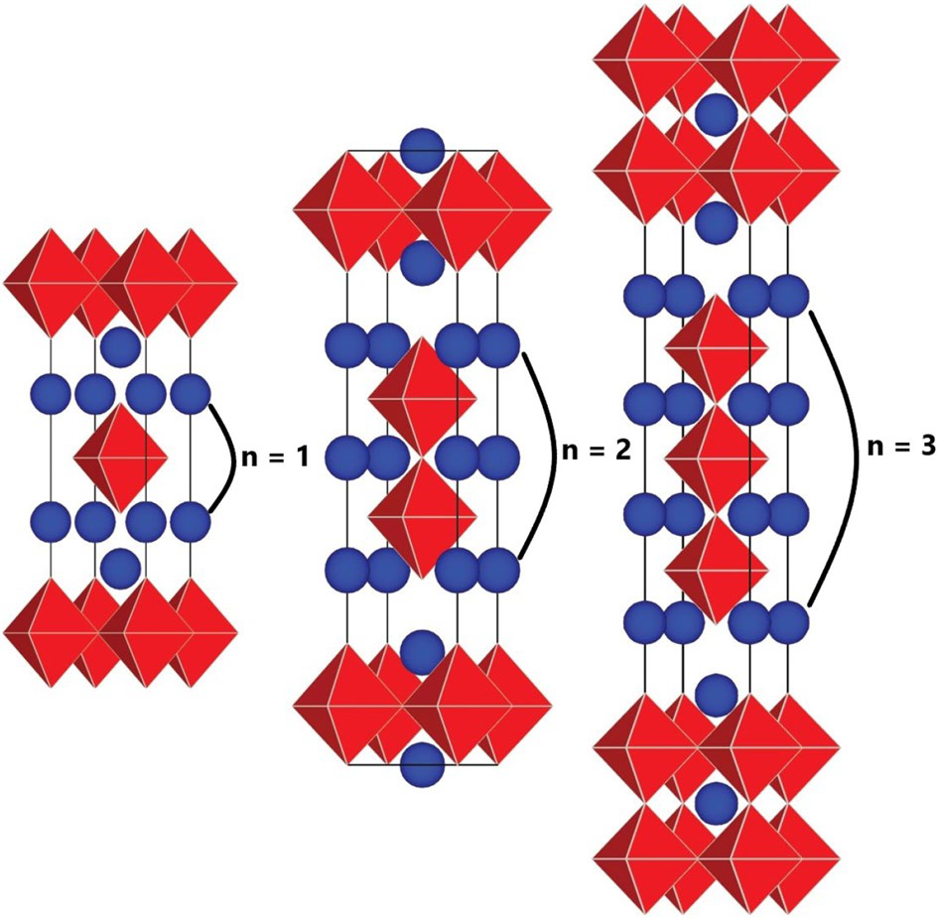

**Figure 3.** Simplified illustration of Ruddlesden–Popper phase’s structure. The number of perovskite layers sandwiched defines

the phase of the material. Adapted from Ref. 71.

oxygen defects. Ruddlesden–Popper phases’ materials further take care of strontium segregation problem—a main problem associated with the state-of-the-art LSCF cathode materials—because Ruddlesden–Popper phases are composed of different constituents and do not necessarily contain Sr.

Lower-order *n* = 1 Ruddlesden–Popper phase materials have a robust capability of storing a considerable amount of intersti-tial oxygen in their structure which bestowed the materials with significant oxide-ion conductivity. This renders the materials MIEC at intermediate temperatures which is the main motiva-tion of intense research focus on these materials.[72,73] Thus, *n* = 1 phases such as LNO, PNO and NNO have been studied extensively. With the lower-order phases such as LNO and PNO, the main issue though is the phase stability under oper-ating conditions, which unfortunately restricts their use as IT-SOFC cathodes.[35,74–78] Even doped lower-order phases such as cobalt-doped LNO, ­La2Ni0.9Co0.1O4+δ, studied by Amow and co-workers observed extensive decomposition.[77]   
The impurity ­Ni2+/Ni3+ phase formation at high tempera-tures in the *n* = 1 R-P phase originates from the In stoichiomet-ric ­La2NiO4 is, Ni exists mainly in ­Ni2+ state, which is stable only at temperatures over 1100°C[79] but in higher-order phases Ni tend to be predominantly in ­Ni3+ state, which is favourably stable below 900°C. Therefore, higher-order phases such as ­La4Ni3O9.78 (L4N3), ­Pr4Ni3O10±δ (P4N3) and ­La2Pr2Ni3O10±δ(L2P2N3) comprising predominantly of ­Ni3+, expectedly offer long-term stability.[80–82]   
This was confirmed by Skinner and co-workers who observed that higher-order phases show increased stability with no impurity phase appearing after 2 weeks of heating of *n* = 2 and 3 phases at 900°C unlike lower-order phases which

**Prospective**



show an impurity phase.[79] While this is promising and has been confirmed by several studies,[13,75,76,82–86] we are leav-ing discussion on Ruddlesden–Popper phase materials limited here and readers are invited to read the dedicated review on the cathode application of these materials published recently by M.

Yatoo and S. Skinner.[87]

**Materials for electrolytes**   
The electrolyte for SOFCs is a dense ceramic material. It is through this ceramic layer that oxide ions migrate to the anode site, and thus, the primary requirement for electrolyte materials is that they should display very good oxide-ion conductivity. The internal resistance of an electrolyte material to oxide-ion transport and the distance to be travelled by oxide ions from cathode to anode is of utmost importance as far as material performance is concerned.

Further, to avoid losses and thus have better efficiency, electrolyte materials ideally should have zero electronic con-ductivity so that electrons generated through the anode reac-tion are not transported through the electrolyte to the cathode to short-circuit the cell. Further, it should be unreactive with electrode materials and have a matching TEC with that of other components of the cell.

The electrolyte for SOFCs is a dense ceramic material. It is through this ceramic layer that oxide ions migrate to the anode site, and thus, the primary requirement for electrolyte materials is that they should display very good oxide-ion conductivity. Yttria-stabilised zirconia, ­ZrO2–Y2O3 (YSZ), is the most com-mon electrolyte material for SOFCs.[18,40] It has good mechani-cal properties and is chemically stable over a wide range of operating temperatures and oxygen partial pressures. The material is composed of ­ZrO2, which is stabilised by ­Y2O3 or other dopants like MgO and ­Sc2O3.[40,88] The ionic conductivity of this electrolyte material depends on the nature and amount of dopant being used because it is these dopants which create oxygen vacancies in zirconia, which in turn are responsible for oxide-ion conduction in the electrolyte.[40,88,89]   
However, the formation of insulating phases at operating temperatures when YSZ electrolyte is used with common cath-ode materials such as LSC, LSCM and LSCF, brings chemical stability issues into the picture, and because insulating phases like ­SrZrO3 and ­La2Zr2O7 have less ionic conductivity than electrolyte material, the cell performance is reduced with time.[88–93]   
Ceria ­(CeO2) doped with gadolinium ions ­(Gd3+) has been found to be promising in terms of its ionic conductivity for use as a SOFC electrolyte. ­Ce0.9Gd0.1O1.95 (CGO10) composition has been found to have better ionic conduction than YSZ.[94,95] The TEC of CGO10 is 13.5 × ­10–6 ­K−1, thus, making it compat-ible with other cell components.[96] However, in CGO electro-lytes under anodic conditions at operating temperatures, ­Ce4+ ions are reduced to ­Ce3+ ions, and this is responsible for n-type electronic conduction, which short circuits the cell, thereby reducing the performance.[95,97]

Recently magnesium-doped lanthanum gallate, ­La*x*Sr1−*x*Ga*y*Mg1−*y*O3−δ (LSGM) because of its good ionic con-ductivity has been used as an electrolyte. This material exhibits excellent oxide-ion conductivity in the intermediate tempera-ture range and, thus, is suitable for studies where the goal is to develop materials for IT-SOFCs such as this work.[98] The origin of this superior ionic conductivity is the vacancies cre-ated in the perovskite structure of lanthanum gallate ­(LaGaO3) by doping strontium and magnesium at A and B sites, respec-tively. In particular, two main compositions being used by researchers are ­La0.8Sr0.2Ga0.8Mg0.2O3−δ (LSGM8282) and ­La0.9Sr0.1Ga0.8Mg0.2O3−δ (LSGM9182). LSGM8282 presents the best ionic conductivity of 0.14 S ­cm−1 at 700°C as com-pared to the relatively lower value of 0.12 S ­cm−1 at the same temperature.[99] These materials further show compatible TEC ~12.0 × ­10–6 ­K−1 and are, thus, widely used as electrolytes in IT-SOFCs research. Figure 4 demonstrates the comparison of ionic conductivity of the three conventional electrolyte materi-als discussed.[100]

**Materials for anodes**   
The primary role of anode material in a cell is to catalyse the fuel oxidation and then to conduct the electrons generated by the oxidation of fuel to the external circuit for useful work. Thus, a typical anode material should possess the good catalytic activity and electronic conductivity. It should also have good ionic conductivity for conducting oxide ions. Furthermore, the ability of the anode material to catalyse fuel oxidation assumes significance as far as cell efficiency is concerned.

A typical anode material should possess good catalytic activity and electronic conductivity to sufficiently fulfil its primary role to catalyse the fuel oxidation and then to con-duct the electrons generated by oxidation of the fuel to the

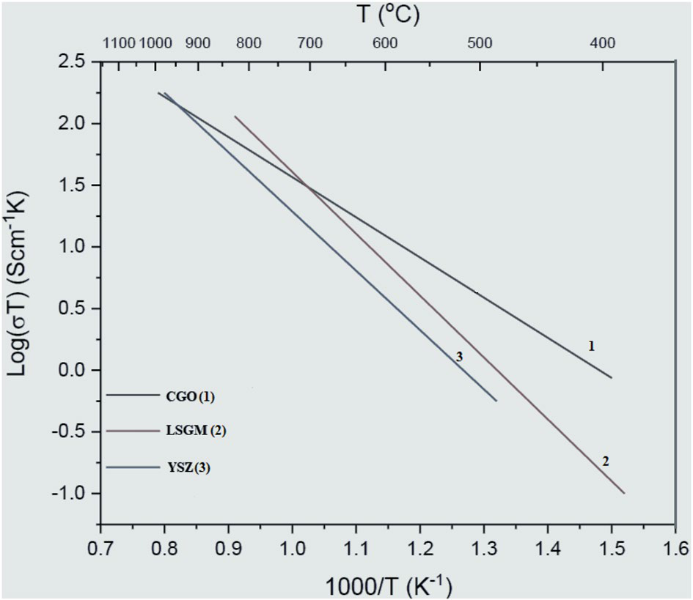

**Figure 4.** Comparison of ionic conductivity of three main electro-lyte materials.

MRS COMMUNICATIONS·VOLUME XX · ISSUE xx ·www.mrs.org/mrc5



external circuit for useful work. Nickel is a good conductor and further acts as a catalyst for hydrogen oxidation, but because of high TEC, it is not mechanically compatible with electrolytes such as YSZ.[12] Therefore, nickel on its own as anode is avoided but is used in the form of a composite.

A recent trend in developing anode materials is to have MIEC materials with a porous structure. Nickel, because of its good catalytic properties and economic viability, is the most common material used for anodes.[18] Ni dispersed over YSZ is, thus, the most commonly used anode mate-rial,[101] and there are also reports where cermets of Ni with ceria doped with gadolinia—that is Ni-CGO—outperform the Ni–YSZ anode.[102] The main problem with Ni–YSZ is that it suffers from carbon deposition and sulphur poisoning which negatively impacts the electrochemical performance of the devices based on this anode. Despite the shortcom-ings, Ni–YSZ is a state-of-the-art anode for high-tempera-ture SOFCs because of its high electrochemical activity and mechanical stability.

For intermediate temperature SOFCs, however, Ni–CGO is the popular anode material. While CGO on its own lacks electronic conductivity—which is, therefore, compensated by addition of Ni—it shows high ionic conductivity.[103] A further drawback of Ni–CGO anode is its mechanical strength, but it shows reduced carbon deposition when used with hydrocar-bon fuels and, therefore, is a vital alternative to Ni–YSZ-based anode materials.[104] The anode, however, is relatively less sig-nificant than the electrolyte and cathode because of its less limiting role in cell performance.

**Conclusions**   
Arguably the most significant series of conferences—the United Nations Climate Change Conference—was recently concluded in Sharm El Sheikh, Egypt. More commonly referred to as the Conference of the Parties (COP), it is the 27th edition (COP27) and lays bare the significance of the devastating impact of fossil fuels on our environment. In this context, technologies such as SOFCs assume central importance and, therefore, require a particular focus by scientists and technologists. Advancement in the search for new materials is one way to solve the chal-lenges faced by energy storage and conversion technologies and SOFCs are one such technology where advancement in materials has proved critical. There are further many opportu-nities to develop layered oxide materials such as perovskites, double perovskites and Ruddlesden–Popper phase materials, including the development of composite electrodes for both fuel cell and electrolysis modes of operation. In this review article, we discussed the prominent materials families cur-rently being investigated by the SOFCs community for differ-ent components of SOFCs, and we believe that looking for new materials families and improving the performance of already identified materials will be instrumental in further developing the SOFCs technology.

6MRS COMMUNICATIONS·VOLUME XX · ISSUE xx ·www.mrs.org/mrc

**Open Access**  
 This article is licensed under a Creative Commons Attribution 4.0 International License, which permits use, sharing, adapta-tion, distribution and reproduction in any medium or format, as long as you give appropriate credit to the original author(s) and the source, provide a link to the Creative Commons licence, and indicate if changes were made. The images or other third party material in this article are included in the article’s Creative Com-mons licence, unless indicated otherwise in a credit line to the material. If material is not included in the article’s Creative Com-mons licence and your intended use is not permitted by statutory regulation or exceeds the permitted use, you will need to obtain permission directly [from the copyright holder. To view a copy](http://creativecommons.org/licenses/by/4.0/) of this licence, visit [http://​creat​iveco​mmons.​org/​licen​ses/​by/4.​0/](http://creativecommons.org/licenses/by/4.0/).

**References**

1. C.Y. Wang, T. Liu, X.G. Yang, S. Ge, N.V. Stanley, E.S. Rountree, Y. Leng, B.D. Mccarthy, Nature **611**, 485 (2022)   
2. G. Wang, L. Zhang, J. Zhang, Chem. Soc. Rev **41**, 797–828 (2012) 3. P. Simon, Y. Gogotsi, Nat. Mater. **7**, 845–854 (2008)   
4. J.P. Baboo, M.A. Yatoo, M. Dent, E. Hojaji Najafabadi, C. Lekakou, R.

Slade, S.J. Hinder, J.F. Watts, Energies (Basel) **15**, 2332 (2022). [https://](https://doi.org/10.3390/en15072332)​[doi.​org/​10.​3390/​en150​72332](https://doi.org/10.3390/en15072332)   
5. J. Baboo, E. Jakubczyk, M.A. Yatoo, M. Phillips, S. Grabe, M. Dent, S.

Hinder, J. Watts, C. Lekakou, J. Power Sources **561**, 232762 (2023).

[https://​doi.​org/​10.​1016/j.​jpows​our.​2023.​232762](https://doi.org/10.1016/j.jpowsour.2023.232762)   
6. M.A. Dar, S. Dinagaran, D. Govindarajan, S. Rafi Ahamed, F. Habib, C.

Siva, A.V. Moholkar, Z. Ahmad, M.A. Yatoo, J. Alloys Compd. **958**, 170523 (2023)   
7. Z. Ahmad, W. Kim, S. Kumar, T.H. Yoon, J.S. Lee, ACS Appl. Energy Mater.

**3**, 6743–6751 (2020)   
 8. G. Kaur, *Intermediate temperature solid oxide fuel cells: electrolytes,*  *electrodes and interconnects* (Elsevier, Amsterdam, 2019)   
 9. M. Singh, D. Zappa, E. Comini, Int. J. Hydrog. Energy **46**, 27643–27674 (2021)  
 10. C. Sun, R. Hui, J. Roller, J. Solid State Electrochem. **14**, 1125–1144 (2010)  
 11. N.H. Menzler, F. Tietz, S. Uhlenbruck, H. Peter Buchkremer, D. Stöver, J.

Mater. Sci. **45**, 3109–3135 (2010)  
 12. S.C. Singhal, Solid State Ion. **135**, 305–313 (2000) 13. P. V. Vibhu, PhD Thesis, University of Bordeaux, 2016.

14. A. Lashtabeg, S.J. Skinner, J. Mater. Chem. **16**, 3161–3170 (2006) 15. J.T.S. Irvine, D. Neagu, M.C. Verbraeken, C. Chatzichristodoulou, C.

Graves, M.B. Mogensen, Nat. Energy **1**, 15014 (2016)  
 16. A. Grimaud, F. Mauvy, J. Marc Bassat, S. Fourcade, M. Marrony, J. Claude Grenier, J. Mater. Chem. **22**, 16017–16025 (2012)  
 17. N.N.M. Tahir, N.A. Baharuddin, A.A. Samat, N. Osman, M.R. Somalu, J.

Alloys Compd. **894**, 162458 (2022)  
 18. N.Q. Minh, T. Takahashi, *Science and technology of ceramic fuel cells*  (Elsevier, Oxford, 1995)  
 19. N.Q. Minh, J. Am. Ceram. Soc. **76**, 563–588 (1993)  
 20. B.A. Boukamp, Nat. Mater. **2**, 294 (2003)  
 21. H. Yokokawa, N. Sakai, T. Kawada, M. Dokiya, Solid State Ion. **52**, 43–56 (1992)  
 22. H. Taimatsu, K. Wada, H. Kaneko, H. Yamamura, J. Am. Ceram. Soc. **75**, 401–405 (1992)  
 23. J. Mizusaki, Y. Yonemura, H. Kamata, K. Ohyama, N. Mori, H. Takai, H.

Tagawa, M. Dokiya, K. Naraya, T. Sasamoto, H. Inaba, T. Hashimoto, Solid State Ion. **132**, 167–180 (2000)  
 24. A. Hammouche, E. Siebert, A. Hammou, Mater. Res. Bull. **24**, 367–380 (1989)  
 25. F. Tietz, I. Arul Raj, M. Zahid, D. Stöver, Solid State Ion. **177**, 1753–1756 (2006)

**Prospective**



26. B. Guan, W. Li, X. Zhang, A. Wedig, R. Merkle, J. Maier, S. Stämmler, B.

Stuhlhofer, J. Hwang, Y. Ando, S. Watanabe, ECS Trans. **68**, 549–556 (2015)  
 27. T. Ishiham, T. Kudo, H. Matsuda, Y. Takita, J. Am. Ceram. Soc. **77**, 1682– 1684 (1994)  
 28. A. Petric, P. Huang, F. Tietz, Solid State Ion. **135**, 719–725 (2000) 29. H. Ullmann, N. Trofimenko, F. Tietz, D. Stöver, A. Ahmad-Khanlou, Solid State Ion. **138**, 79–90 (2000)  
 30. J. Hwang, Y. Ando, S. Watanabe, ECS Trans. **68**, 549–556 (2015) 31. L.W. Tai, M.M. Nasrallah, H.U. Anderson, D.M. Sparlin, S.R. Sehlin, Solid State Ion. **76**, 273–283 (1995)  
 32. D.-ping Huang, Q. Xu, F. Zhang, W. Chen, H.-xing Liu, J. Zhou, Mater. Lett.

**60**, 1892–1895 (2006)  
 33. H. Zhao, F. Mauvy, C. Lalanne, J.M. Bassat, S. Fourcade, J.C. Grenier, Solid State Ion. **179**, 2000–2005 (2008)  
 34. G. Amow, J. Au, I. Davidson, Solid State Ion. **177**, 1837–1841 (2006) 35. G. Amow, I. Davidson, S. Skinner, Solid State Ion. **177**, 1205–1210 (2006) 36. R.K. Sharma, M. Burriel, L. Dessemond, J.-M. Bassat, E. Djurado, J.

Power Sources **325**, 337–345 (2016)  
 37. V. Vibhu, A. Rougier, C. Nicollet, A. Flura, S. Fourcade, N. Penin, J.-C.

Grenier, J.-M. Bassat, J. Power Sources **317**, 184–193 (2016)  
 38. J. Fleig, Annu. Rev. Mater. Res. **33**, 361–382 (2003)  
 39. M.J.L. Østergård, C. Clausen, C. Bagger, M. Mogensen, Electrochim. Acta **40**, 1971–1981 (1995)  
 40. O. Yamamoto, Y. Arachi, H. Sakai, Y. Takeda, N. Imanishi, Y. Mizutani, M.

Kawai, Y. Nakamura, Ionics (Kiel) **4**, 403–408 (1998)  
 41. A.V. Berenov, A. Atkinson, J.A. Kilner, E. Bucher, W. Sitte, Solid State Ion.

**181**, 819–826 (2010)  
 42. S.R. Sehlin, H.U. Anderson, D.M. Sparlin, Solid State Ion. **78**, 235–243 (1995)  
 43. A.N. Petrov, O.F. Kononchuk, A.V. Andreev, V.A. Cherepanov, P. Kofstad, Solid State Ion. **80**, 189–199 (1995)  
 44. L.W. Tai, M.M. Nasrallah, H.U. Anderson, D.M. Sparlin, S.R. Sehlin, Solid State Ion. **76**, 259–271 (1995)  
 45. M.A. Señarı́s-Rodrı́guez, J.B. Goodenough, J. Solid State Chem. **118**, 323–336 (1995)  
 46. Y. Teraoka, H.M. Zhang, K. Okamoto, N. Yamazoe, Mater. Res. Bull. **23**, 51–58 (1988)  
 47. L. Qiu, T. Ichikawa, A. Hirano, N. Imanishi, Y. Takeda, Solid State Ion. **158**, 55–65 (2003)  
 48. W.-H. Kim, H.-S. Song, J. Moon, H.-W. Lee, Solid State Ion. **177**, 3211–3216 (2006)  
 49. S.P. Simner, J.P. Shelton, M.D. Anderson, J.W. Stevenson, Solid State Ion.

**161**, 11–18 (2003)  
 50. J.M. Ralph, A.C. Schoeler, M. Krumpelt, J. Mater. Sci. **36**, 1161–1172 (2001)  
 51. B.C.H. Steele, Solid State Ion. **134**, 3–20 (2000)  
 52. V. Dusastre, J.A. Kilner, Solid State Ion. **126**, 163–174 (1999)  
 53. W.G. Wang, M. Mogensen, Solid State Ion. **176**, 457–462 (2005)  
 54. A. Tsoga, A. Gupta, A. Naoumidis, P. Nikolopoulos, Acta Mater. **48**, 4709– 4714 (2000)  
 55. S.P. Simner, M.D. Anderson, M.H. Engelhard, J.W. Stevenson, Electrochem.

Solid-State Lett. **9**, A478–A481 (2006)  
 56. N. Miura, Y. Okamoto, J. Tamaki, K. Morinaga, N. Yamazoe, Solid State Ion.

**79**, 195–200 (1995)  
 57. X. Li, J.-W. Lee, B.N. Popov, J. Power Sources **187**, 356–362 (2009) 58. F.S. Baumann, J. Fleig, M. Konuma, U. Starke, H.-U. Habermeier, J. Maier, J. Electrochem. Soc. **152**, A2074–A2079 (2005)  
 59. M. Finsterbusch, A. Lussier, J.A. Schaefer, Y.U. Idzerda, Solid State Ion. **212**, 77–80 (2012)  
 60. W. Wang, S.P. Jiang, Solid State Ion. **177**, 1361–1369 (2006)  
 61. Z. Lu, J. Zhu, Y. Pan, N. Wu, A. Ignatiev, J. Power Sources **178**, 282–290 (2008)  
 62. J. N. Audinot, Phd Thesis, University of Bordeaux, 1999.

63. S.A. Speakman, R.D. Carneim, E.A. Payzant, T.R. Armstrong, J. Mater. Eng.

Perform **13**, 303–308 (2004)  
 64. A. Tarancon, M. Burriel, J. Santiso, S.J. Skinner, J.A. Kilner, J. Mater. Chem.

**20**, 3799–3813 (2010)  
 65. A.A. Taskin, A.N. Lavrov, Y. Ando, Phys. Rev. B **71**, 134414 (2005)

[View publication stats](https://www.researchgate.net/publication/371240977)

66. A.A. Taskin, A.N. Lavrov, Y. Ando, Prog. Solid State Chem. **35**, 481–490 (2007) 67. G. Kim, S. Wang, A.J. Jacobson, L. Reimus, P. Brodersen, C.A. Mims, J.

Mater. Chem. **17**, 2500–2505 (2007)  
 68. M.H. Ko, Y.S. Yoo, J.-H. Hwang, Ceram. Int. **41**, 4616–4620 (2015)  
 69. S.N. Ruddlesden, P. Popper, Acta Cryst. **11**, 54–55 (1958)  
 70. B.V. Beznosikov, K.S. Aleksandrov, Crystallogr. Rep. **45**, 792–798 (2000) 71. R.G. Palgrave, P. Borisov, M.S. Dyer, S.R.C. Mcmitchell, G.R. Darling, J.B.

Claridge, M. Batuk, H. Tan, H. Tian, J. Verbeeck, J. Hadermann, M.J. Ros- seinsky, J. Am. Chem. Soc. **134**, 7700–7714 (2012)  
 72. V.V. Kharton, A.P. Viskup, E.N. Naumovich, F.M.B. Marques, J. Mater. Chem.

**9**, 2623–2629 (1999)  
 73. J.A. Kilner, S.J. Skinner, Solid State Ion. **135**, 709–712 (2000)  
 74. G. Amow, I. Davidson and S. Skinner, in *Proceedings of the Electrochemical*  *Society SOFC-IX*, Proceedings of the Electrochemical Society SOFC-IX, 2005, 1745.

75. J.-M. Bassat, V. Vibhu, C. Nicollet, A. Flura, S. Fourcade, J.-C. Grenier, A.

Rougier, ECS Trans. **78**, 655–665 (2017)  
 76. V. Vibhu, J.-M. Bassat, A. Flura, C. Nicollet, J.-C. Grenier, A. Rougier, ECS Trans. **68**, 825–835 (2015)  
 77. G. Amow, P.S. Whitfield, I.J. Davidson, R.P. Hammond, C.N. Munnings, S.J.

Skinner, Ceram. Int. **30**, 1635–1639 (2004)  
 78. G. Amow, S.J. Skinner, J. Solid State Electrochem. **10**, 538–546 (2006) 79. C. Munnings, S. Skinner, G. Amow, P. Whitfield, I. Davidson, Solid State Ion.

**177**, 1849–1853 (2006)  
 80. M. Yatoo, PhD Thesis, Imperial College London, 2019. [https://​doi.​org/​10.](https://doi.org/10.25560/89551)​ [25560/​89551](https://doi.org/10.25560/89551)  
 81. M.A. Yatoo, I.D. Seymour, S.J. Skinner, RSC Adv. **13**, 13786–13797 (2023).

[https://​doi.​org/​10.​1039/​D3RA0​1772A](https://doi.org/10.1039/D3RA01772A)  
 82. M.A. Yatoo, S.J. Skinner, ECS Trans. **[1](https://doi.org/10.1039/D3RA01772A)11**, 2405 (2023). [https://​doi.​org/​10.](https://doi.org/10.1149/11106.2405ecst)​ [1149/​11106.​2405e​cst](https://doi.org/10.1149/11106.2405ecst)  
 83. M.A. Yatoo, A. Aguadero, S.J. Skinner, APL Mater. **7**, 8 (2019). [https://​doi.](https://doi.org/10.1063/1.5050249)​ [org/​10.​1063/1.​50502​49](https://doi.org/10.1063/1.5050249)  
 84. M.A. Yatoo, S.S. Kawale, S.J. Skinner, in *Intermediate temperature solid*  *oxide fuel cells*. ed. by G. Kaur (Elsevier, Amsterdam, 2020), pp.315–346.

[https://​doi.​org/​10.​1016/​B978-0-​12-​817445-​6.​00010-7](https://doi.org/10.1016/B978-0-12-817445-6.00010-7)  
 85. M.A. Yatoo, Z. Du, Z. Yang, H. Zhao, S.J. Skinner, Crystals (Basel) **10**, 428 (2020). [https://​doi.​org/​10.​3390/​cryst​10060​428](https://doi.org/10.3390/cryst10060428)  
 86. M.A. Yatoo, Z. Du, H. Zhao, A. Aguadero, S.J. Skinner, Solid State Ion. **320**, 148–151 (2018). [https://​doi.​org/​10.​1016/j.​ssi.​2018.​02.​043](https://doi.org/10.1016/j.ssi.2018.02.043)  
 87. M.A. Yatoo, S.J. Sk[inner, Mater. Today Proc.](https://doi.org/10.1016/j.ssi.2018.02.043) **[56](https://doi.org/10.1016/j.ssi.2018.02.043)**[, 3747–3754 (2](https://doi.org/10.1016/j.ssi.2018.02.043)022). [https://](https://doi.org/10.1016/j.matpr.2021.12.537)​ [doi.​org/​10.​1016/j.​matpr.​2021.​12.​537](https://doi.org/10.1016/j.matpr.2021.12.537)  
 88. [W. Tinglian, L. Xiaofei, K. Chukun, W. We](https://doi.org/10.1016/j.matpr.2021.12.537)ppner, Solid State Ion. **18**, 715–719 (1986)  
 89. S.P.S. Badwal, Solid State Ion. **143**, 39–46 (2001)  
 90. A.M. Hernández, L. Mogni, A. Caneiro, Int. J. Hydrog. Energy **35**, 6031–6036 (2010) 91. Z. Duan, M. Yang, A. Yan, Z. Hou, Y. Dong, Y. Chong, M. Cheng, W. Yang, J.

Power Sources **160**, 57–64 (2006)  
 92. G.C. Kostogloudis, G. Tsiniarakis, C. Ftikos, Solid State Ion. **135**, 529–535 (2000) 93. J.A.M. van Roosmalen, E.H.P. Cordfunke, Solid State Ion. **52**, 303–312 (1992)  
 94. S.J. Skinner, J.A. Kilner, Mater. Today **6**, 30–37 (2003)  
 95. B.C.H. Steele, Solid State Ion. **129**, 95–110 (2000)  
 96. A.J. Jacobson, Chem. Mater. **22**, 660–674 (2010)  
 97. M. Han, X. Tang, H. Yin, S. Peng, J Power Sources **165**, 757–763 (2007) 98. T. Ishihara, H. Matsuda, Y. Takita, J. Am. Chem. Soc. **116**, 3801–3803 (1994) 99. P. Huang, A. Petric, J. Electrochem. Soc. **143**, 1644–1648 (1996)  
 100. N. Preux, A. Rolle, R.N. Vannier, *Functional materials for sustainable energy*  *applications* (Elsevier, Amsterdam, 2012), pp.370–401  
 101. S. Tao, J.T.S. Irvine, Nat. Mater. **2**, 320–323 (2003)  
 102. W.Z. Zhu, S.C. Deevi, Mater. Sci. Eng. A **362**, 228–239 (2003)  
 103. J. Seo, J. Moon, K. Kim, N. Prasad Yerriboina, S. Sahir, S.-Y. Han, J. Elec- trochem. Soc. **146**, 1273–1278 (1999)  
 104. S. Tao, J.T.S. Irvine, Chem. Rec. **4**, 83–95 (2004)

**Publisher’s Note** Springer Nature remains neutral with regard to jurisdictional claims in published maps and institutional affiliations.

MRS COMMUNICATIONS·VOLUME XX · ISSUE xx ·www.mrs.org/mrc7